Room B
BQ1 Infected Ventral Hernia Mesh
Infected Ventral Hernia Mesh
Stem: A 49-year-old female is seeking second opinion from you for a recurrent hernia. Her hernia repair history includes prior previous open repairs; using a permanent synthetic mesh. Her most recent repair 1 year prior to presentation involved open component separation with biologic mesh reinforcement.
She initially developed some purulent drainage from the wound, she tells you, it was cleaned by her surgeon in the office. However, since that time, she has had ongoing drainage from her wound and she didn’t follow up.
Past medical and surgical history: hypertension, Roux-en-Y gastric bypass, open colon surgery, and open appendectomy.
PE: 2 × 1-cm opening in the midportion of her abdomen with chronic granulation tissue and mild drainage. BMI of 27 kg/m2 and

What is your differential diagnosis and work up?
- Prosthetic mesh infection
- Persistent seroma
- Enterocutaneous fistula (ECF

- CT scan: Prosthetic mesh with significant inflammation and a small fluid collection, contrast seen through the bowel loop underneath the mesh but not extending into the inflammatory process.
- CBC, CMP normal labs
- Culture from her wound: MSSA.
What is your diagnosis and what will you offer to and counsel the patient?
- Most likely Diagnosis is chronic infected mesh.
- Given failed conservative management, I will offer surgical mesh excision.
- Informed consent for – Removal of infected mesh, address any underlying GI tract issues.
- Counsel patient hat once mesh is removed, hernia is at high risk of recurrence. May need biological mesh to facilitate closure.
- Interval definitive abdominal wall hernia repair afterwards.
Describe the operation?
- Laparotomy in the area of infected mesh.
- Complete adhesiolysis and evaluation of bowel and surrounding structures
- Repair any gastrointestinal issues as appropriate.
- Excision of all prosthetic mesh taking care to preserve abdominal wall muscles.
- Utilize landmarks such as transfascial sutures or tacks to identify periphery of the mesh.
- Repair the resulting hernia defect with primary closure versus resorbable mesh.
Examiner: In this scenario, the patient had several pieces of infected mesh as a result of her multiple previous hernia repairs. After adhesiolysis, there was no evidence of gastrointestinal involvement. All of the mesh was able to be completely removed, and the resulting hernia defect was repaired with slowly resorbable suture.
Scenario: This patient developed a recurrent hernia 9 months after surgery, she comes back to you to consider repair. Ct scan shows wide midline gap > 20 cm. , what will you offer the patient?
- Component Separation.
Describe the surgery?
- Perform complete adhesiolysis of the entire anterior abdominal wall to the paracolic gutters to allow muscular components to slide to the midline during reconstruction.
- Elevate lipocutaneous flaps 2 cm lateral to the linea semilunaris, edge of the rectus muscle.
- Incise the external oblique fascia and separate the external and internal oblique muscles in their avascular plane.
- Continue the dissection 3–4 cm above the costal margin and inferiorly to the inguinal ligament.
- Release the posterior rectus sheath by making an incision 1 cm lateral to the linea alba.
- Develop the retromuscular plane out to the linea semilunaris while preserving the neurovascular bundles to the rectus muscle.
- Place an appropriately sized biologic graft or mesh as an underlay.
- Drains placed over the mesh.
- Remove excess devascularized skin,
- Close over multiple drains.

BQ2 Pediatric Duodenal Hematoma.
PEDIATRIC DUODENAL HEMATOMA
Stem: An 11-Year-old boy presents to the emergency department with worsening abdominal pain, associated with nausea and vomiting, all of which started after he fell while skateboarding and landed with his abdomen on a rail. His exam is significant for moderate epigastric tenderness. His vital signs are normal, and his labs are remarkable only for a serum amylase of 150.

What is your differential diagnosis?
1. Duodenal Hematoma with possible obstruction
2. Hollow viscus injury
3. Pancreatic laceration (with or without duct injury)

What Additional Workup or Studies you need ?!
1. CT Abdomen and Pelvis with IV contrast
2. ATLS / Trauma exam

CT scan demonstrates an isolated hematoma in the third portion of the duodenum, there is no current evidence of obstruction. On re-examination the patient looks mildly better after pain medication. What would you like to do?
1. Admit for observation
2. NPO
3. Monitor for developing obstruction, these patients frequently develop
obstruction in the 24-48 hours post injury time frame.

48 hours after admission, he develops worsening nausea and has several episodes of vomiting. He is unable to tolerate PO intake. Diagnosis and next step?
1. Duodenal hematoma has obstructed due to fluid shifts
2. NPO, NG tube decompression, consider early TPN
3. Attempt non-operative management for 5-10 days (some sources say as long as
2-3 weeks), most cases of duodenal hematoma will resolve with non-operative
management.
4. Consider exploration and unroofing of hematoma if no improvement after 1
week.
5. Upper GI with gastrografin to prove resolution of obstruction prior to starting PO nutrition

Let’s say you end up in the OR and you find a duodenal hematoma intra-op during , how would you manage it?

- Perform Kocher maneuver to fully explore the duodenum, looking for any evidence of perforation.
- Methylene blue via NGT, . If concerned about a missed full thickness injury.
- Evacuate If hematoma causing >50% obstruction.
- Unroof with longitudinal incision over lateral aspect of duodenum.
- Do not damage mucosa.
- Ligate bleeding vessels to achieve hemostasis.
- Close the proximal portion of the incision with interrupted sutures.
- Leave midportion open to prevent hematoma re-ccumulation.
- Leave a drain.

Scenario 4: Suppose this was a 9-year-old boy stabbed in the RUQ. During laparotomy, a full thickness laceration of the duodenum is noted. What is your decision making for approaching this?
- Repair if
  - < 24 hours since injury
  - Not involving the ampulla, pancreas or CBD
  - Distal D2 – D4
  - <50% transection then typically able to repair.

- What if there is a complete transaction?
  - Ensure no ampullary involvement.
  - Debride and end to end anastomosis.

- Protecting duodenal repair:
  - Omental buttress
  - Jejunal serosal patch
  - Pyloric exclusion
  - Feeding / drainage tubes

- What if there is an associated pancreatic injury?
  - Repair duodenum
  - Wide drainage peripancreatic

BQ3 Spontaneous Pneumothorax.
Stem: A 65-year-old man with presents with acute onset shortness of breath. He regularly has dyspnea on exertion but suddenly became short of breath at rest 1 hour ago. He has new right-sided chest pain, which he describes as knife-like and worse on inspiration. He denies recent chest trauma.
PMH: Chronic obstructive pulmonary disease (COPD), hypertension, and a 50 pack-year history of smoking
On physical examination, he is tachycardic, hypertensive, tachypneic, and his oxygen saturation is 85% on room air. He has decreased breath sounds on the right side, decreased chest expansion on the right, and hyperresonance to percussion on the right. His trachea is midline.

What should you do immediately and what is your work up?
- Place on Supplemental oxygen : O2 Sat improved
- EKG: Sinus Tachycardia , no ischemia
- Cardiac Enzymes.
- Chest X-ray
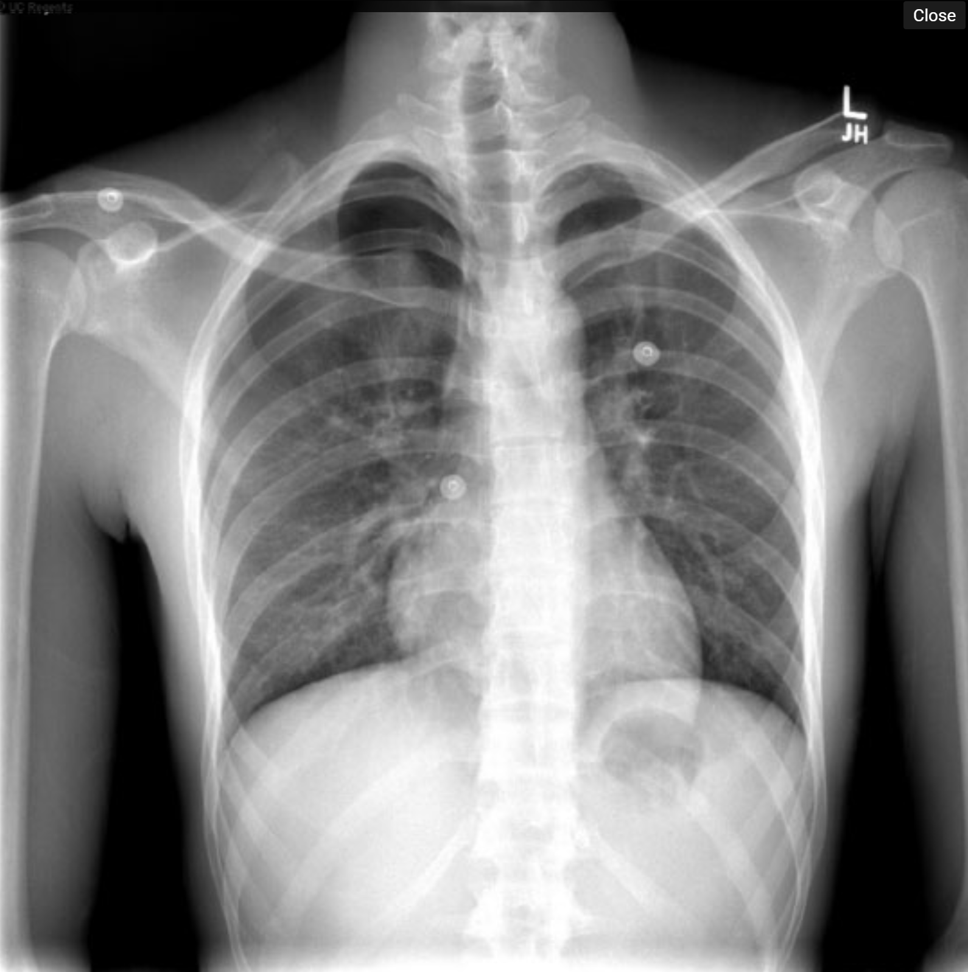
- Bedside Chest US
- CT chest : Right side pneumothorax : highly useful for older patients with chronic lung disease in order to describe the severity and extent of the pathology for surgical planning.
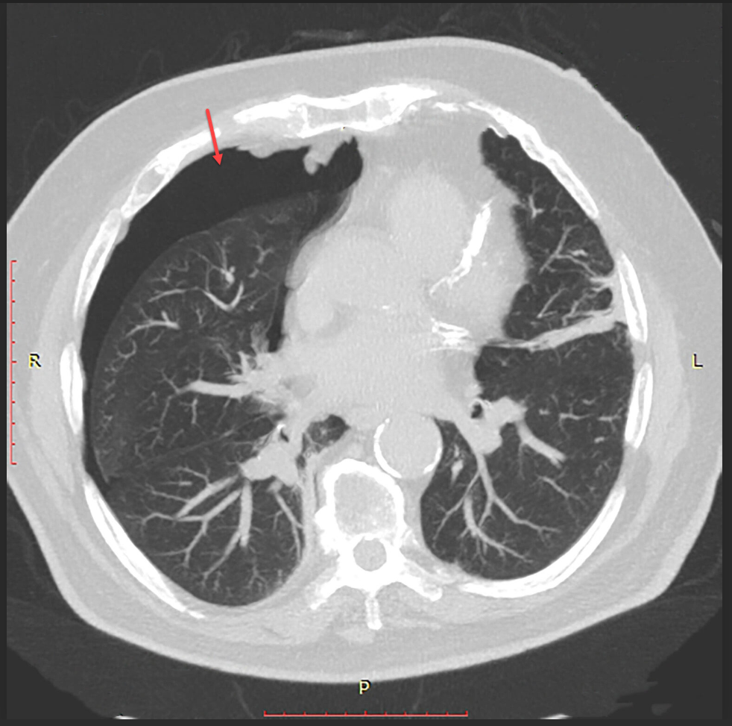

What is your differential diagnosis and management plan?
  - Pneumothorax (Primary / Secondary)
  - MI
  - PE
  - Aortic dissection
  - Pneumonia
  - Tension pneumothorax

Scenario: You placed a chest tube, air leak persisted more than 3 days, what would you do?
- Repeat imaging.
- Consider surgical intervention:
  - Video-assisted mechanical or talc pleurodesis.
  - Blebectomy.
  - Pleural tent procedure.
  - Blood patch of 50 mL of the patient’s own blood.
- Preop evaluation? Patients with long term COPD need cardiac and ABG assessment to make sure they can tolerate one lung ventilation for surgery.
Describe VATS (Video-Assisted Thoracoscopic) Bleb/Bullae Resection and Pleurodesis?
- Double-lumen endotracheal tube.
- Position the patient in the lateral decubitus position with single lung ventilation.
- Place the VATS camera port at the 7th intercostal space in the posterior axillary line.
- Depending on the location of the pathology, one or two additional ports may be placed in the 5th -9th intercostal spaces.
- Grasp the affected tissue and apply the endoscopic stapler across the base of the bullae/bleb. Use a linear GIA staple load.
- Abrade the parietal pleura through the VATS ports. This can be accomplished by using the electrocautery scratch pad, the electrocautery, or the argon beam coagulator.
- Consider mechanical vs. talc pleurodesis
- Remove the ports and insert a single chest tube into the inferior VATS port.

Scenario: After VATS and Bullae resection, patient has a persistent air leak after postoperative day 4, otherwise stable, now what?
- Water seal chest tube and if tolerates, may connect chest tube to a Heimlich valve, (outpatient suctionless device).
- If the patient can tolerate this device for 24 hours inpatient without reexpansion of the pneumothorax or clinical deterioration, then they may be discharged home with the suctionless device and strict return precautions for any worsening of symptoms.
Scenario: What if your patient was healthy 33 Y M , on presentation imaging showed small pneumothorax and patient O2 saturation improved while on oxygen, would you manage differently?
- Patient can be observed, if the pneumothorax is small.
- If the pneumothorax is radiographically stable over 6 hours and there is no progression of symptoms, they may be sent home with close follow-up.

